 Bed Bath & Beyond

**PSI8 8.19.12 Release Run-Book**

***Release Document***



Document Control

| **Revision** | Date | Updated By | Description |
| --- | --- | --- | --- |
| 1 | 06/30/2016 | Saiyyad Md. Imran | Data load document for Gemini Sprint 19.12 |

Contributors

| Name | Email ID | Work Phone |
| --- | --- | --- |
| Saiyyad Md. Imran | simran2@sapient.com |  |
|  |  |  |

Reviewers

| Name | Email ID | Work Phone |
| --- | --- | --- |
| Ashish Abrol | aabrol@sapient.com |  |

Primary Contacts

|  |  |  |  |  |
| --- | --- | --- | --- | --- |
| App | Contact Name | Job Title | E-Mail ID | Work Phone |
|  |  |  |  |  |
|  |  |  |  |  |

*Note: To be contacted in the given order.*

**Table of Contents**

1. Introduction 4

2. Dataload Steps 4

2.1. Pre-requisite 4

2.2. Dataload 4

2.3. Manual Data load 4

2.4. Post Deployment 4

3. Instructions 4

3.1 Template upload steps 4

3.2 Steps to add/update configure Key(s) 12

3.2.1 Update configure Key(s) 14

3.2.2 Update Translations for configure Key(s) 14

3.2.3 Add configure Key(s) 15

3.2.4 Add Translation for configure Key(s) 16

3.2.5 Add configure Key(s) Manually 18

3.3 Update Labels Manually 20

3.4 Delete Labels Manually 24

# Introduction

This document describes the data packet and data load instructions to be followed for current release.

# Dataload Steps

# Pre-requisite

NA

# Dataload

Please refer the table below for data load sheets available in this release and corresponding section to be referred to upload the data.

***Note: Please follow the sequence mentioned in the table below for data load.***

|  |  |
| --- | --- |
| **File Name** | **Section to refer** |
| ConfigKeyTranslation.xls | 3.1 |
| ConfigKeysValue.xls | 3.1 |

# Manual Data load

***Note: These data given in the following files should be uploaded manually. The following spreadsheet can’t be uploaded directly.***

|  |  |
| --- | --- |
| **File Name** | **Section to refer** |
|  |  |

# Post Deployment

N.A.

# Instructions

# Template upload steps

Follow below mentioned steps to upload templates like Labels template, Email template, Registry template, Category landing template etc.

1. 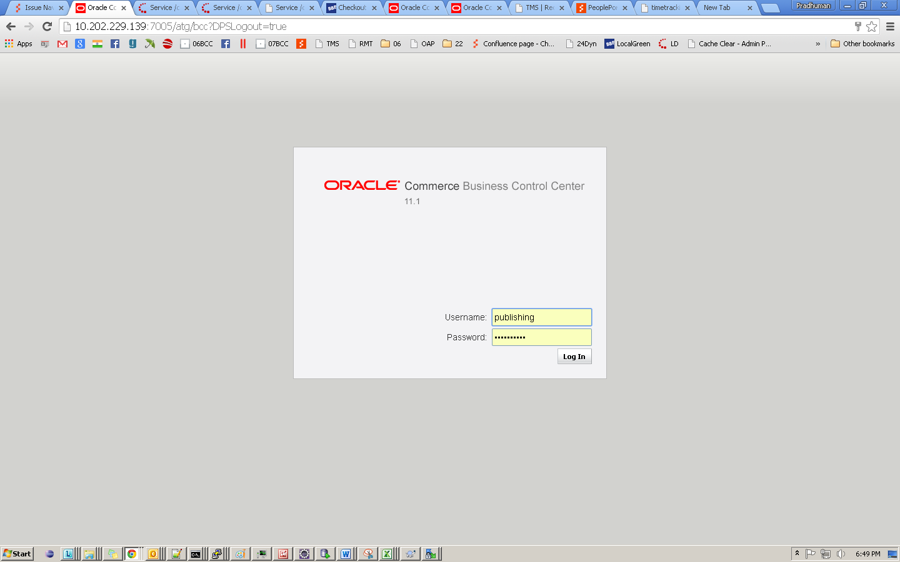Enter User name and password and click on **‘Login In’** button.
2. Click on **‘Commerce Assets’** link in the left navigation.

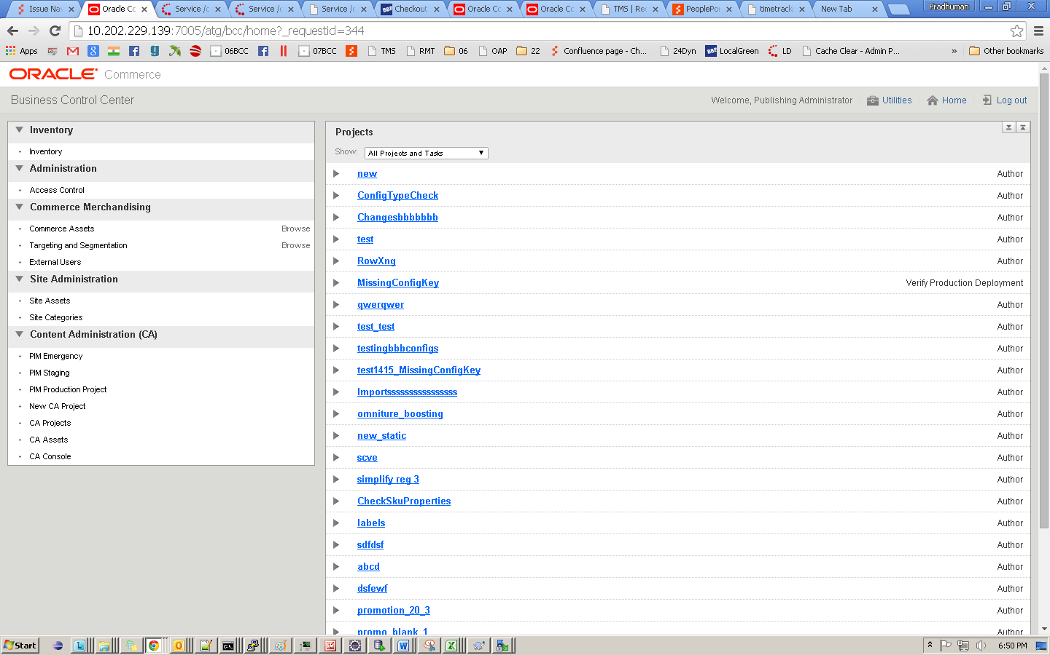

1. Enter Project Name and Project Description and click **‘Continue’** button.

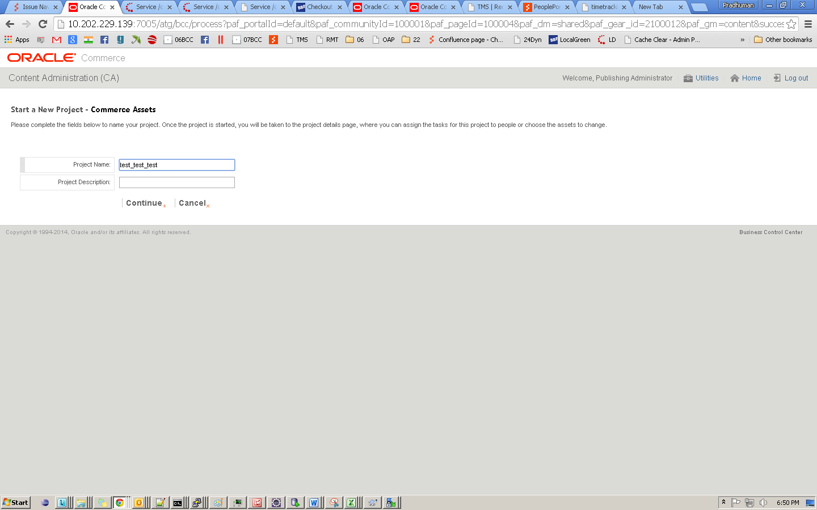

Following window will appear.

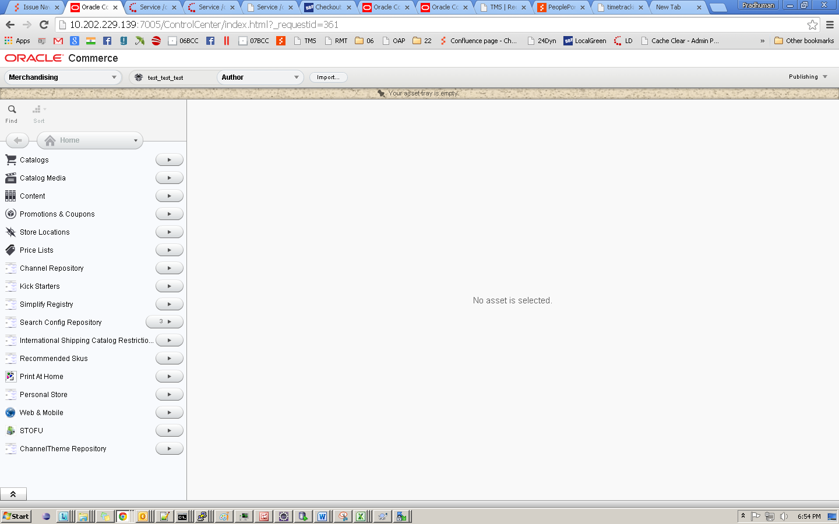

1. Click on the import button at the top.

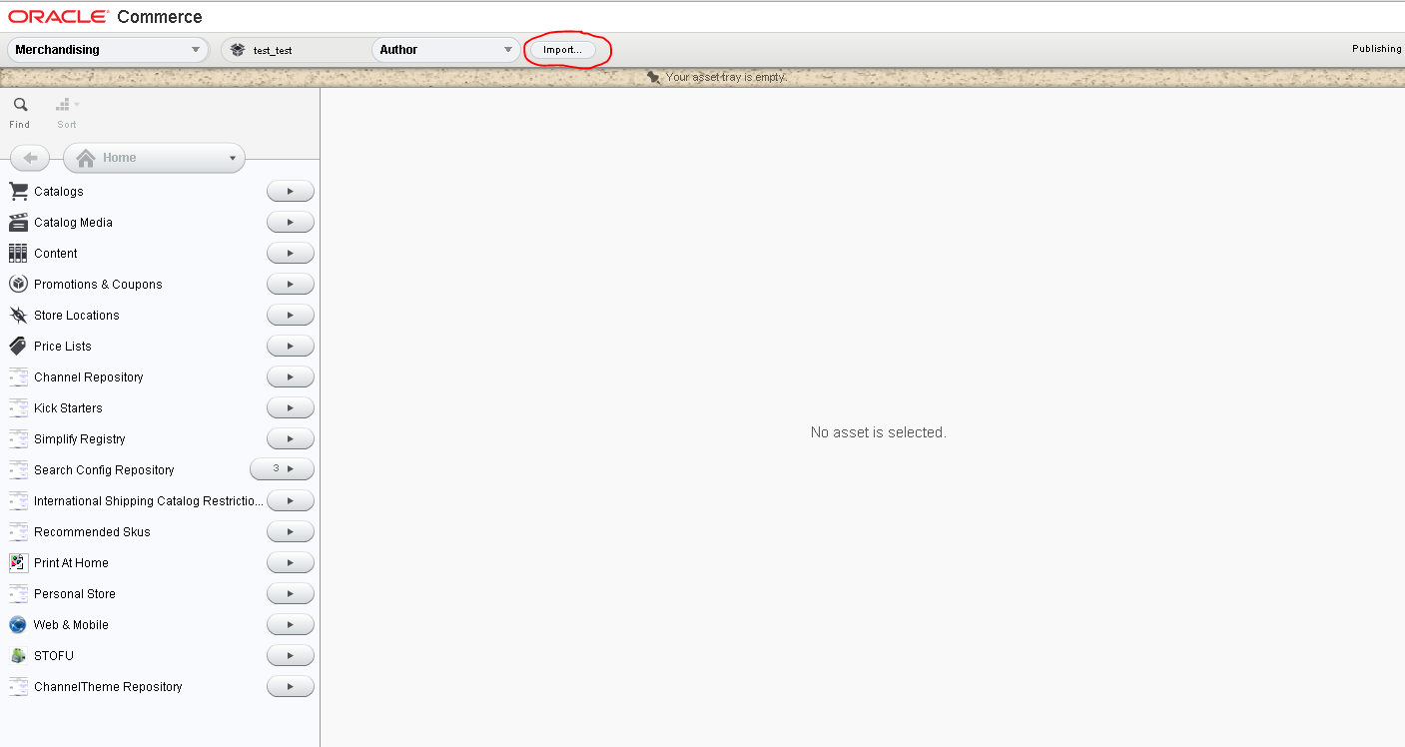

1. Click on **‘Browse…’** button and select the sheet to be imported in the sequence mentioned in section 2.2. Click on **‘Upload’** button.

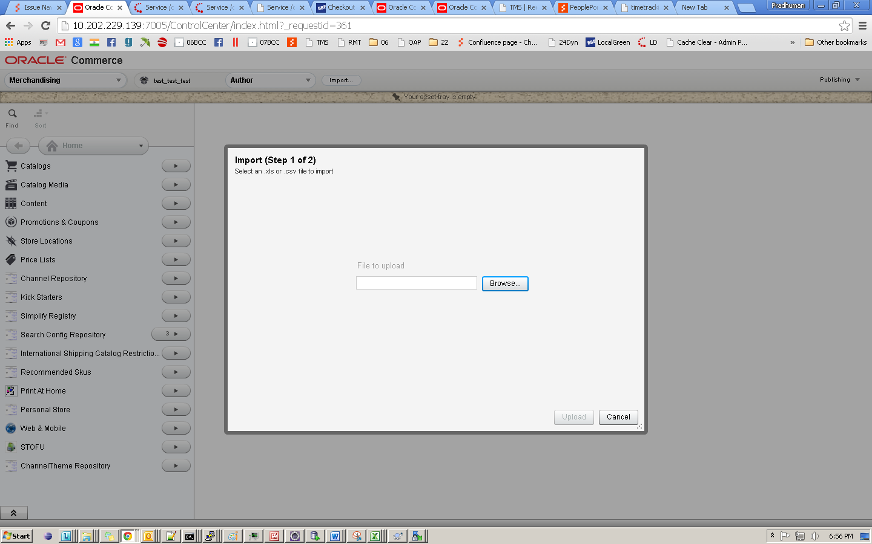

1. Click on **‘Import’** button.

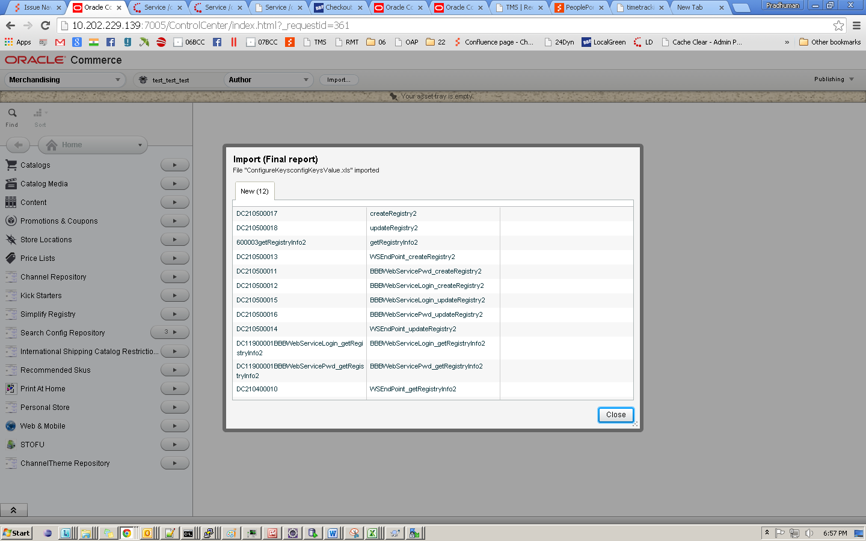

1. Go to the home page and deploy the Project to the Staging and Production.
2. Click on **‘CA Projects’** link.

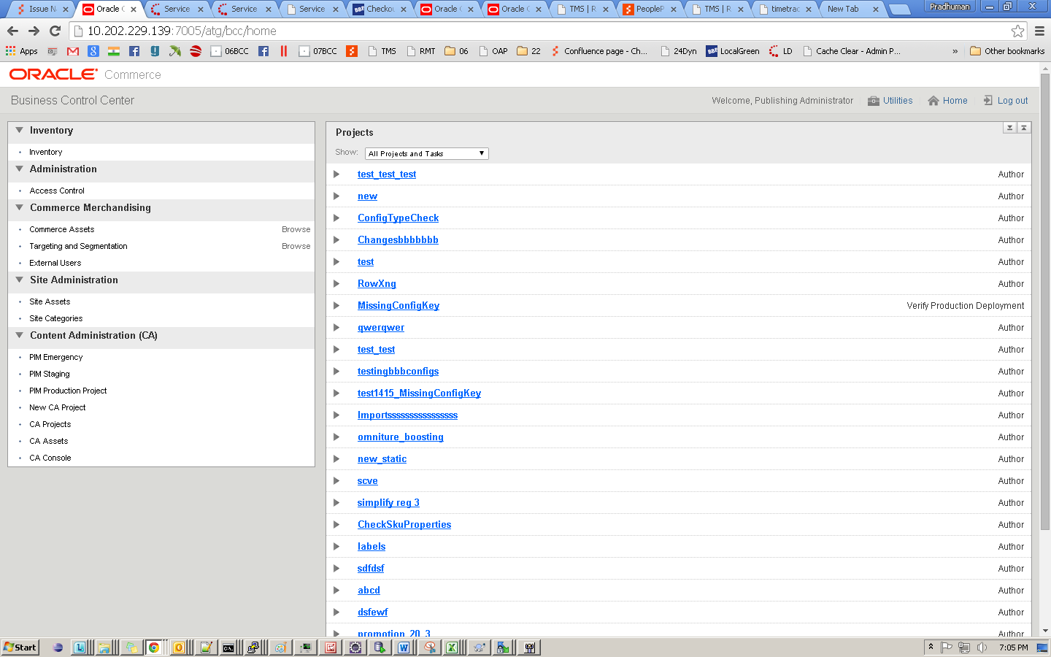

1. Sort Start Date in descending order and find the name of your project and click on project name created in step ‘c’.

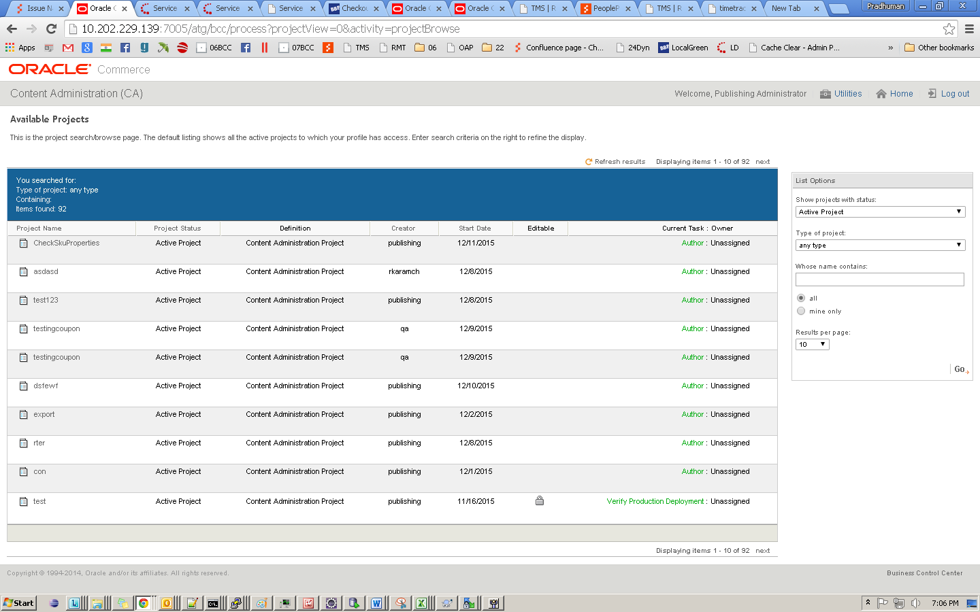

1. Click on Author link of the project @ right of the row

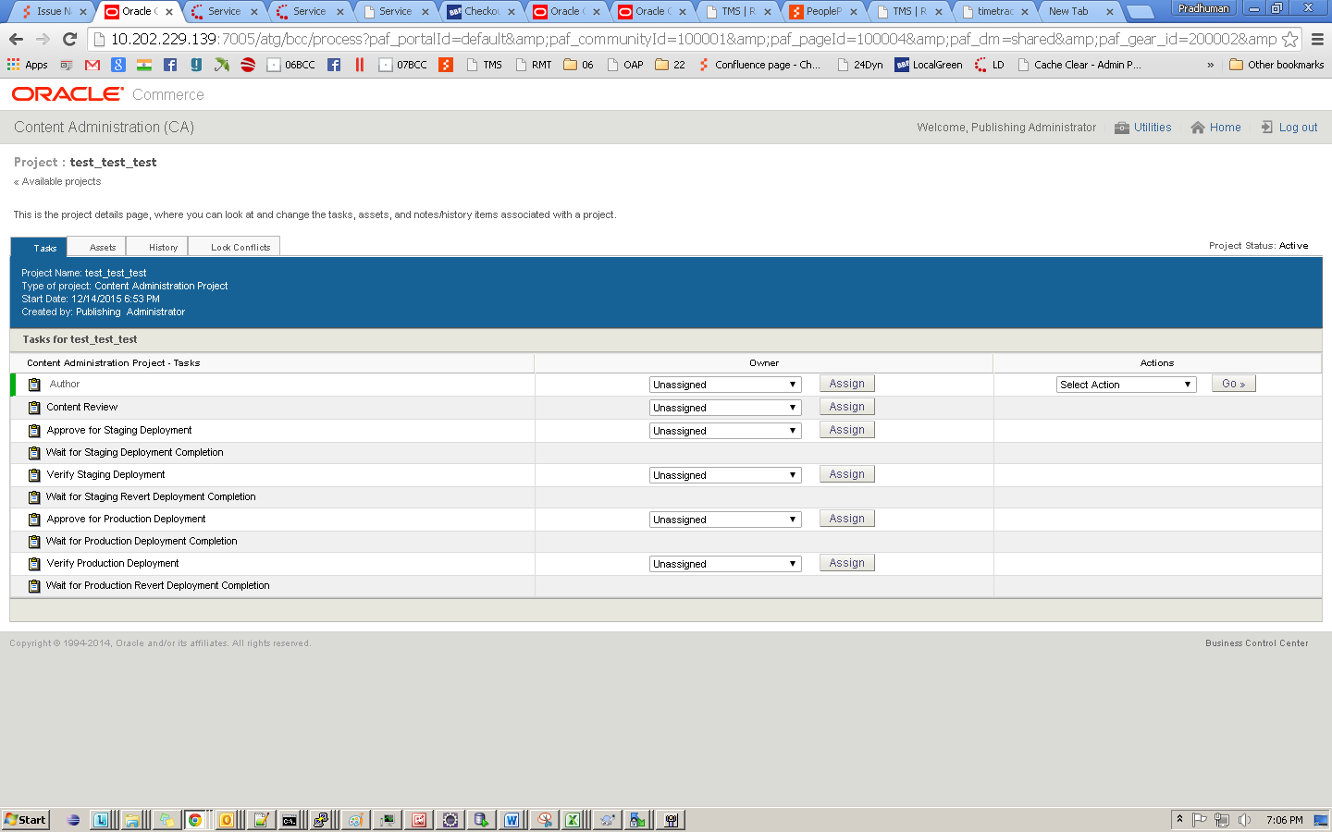

1. Select **‘Ready For Project Review’** option from drop down and click **‘Go’** button and then click **‘OK’** button in flyout at the top.

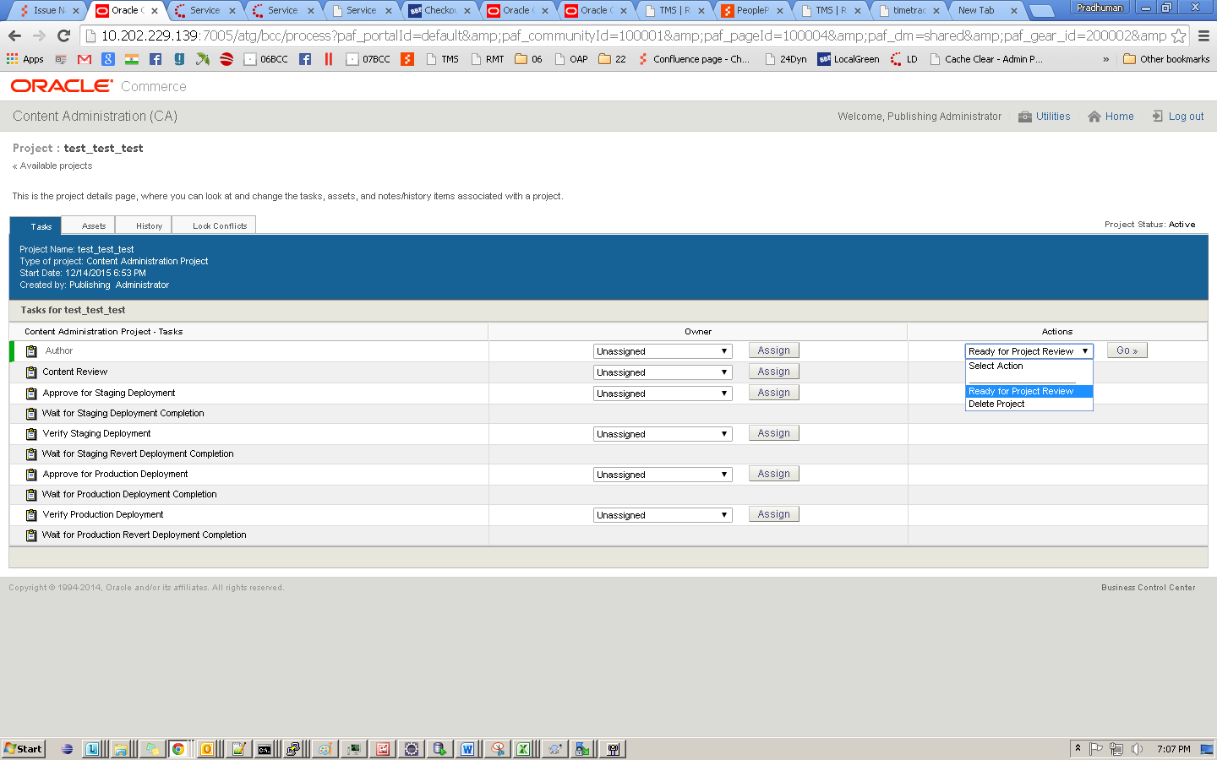

1. Select **‘Approve content’** option from Drop Down and click **‘Go’** button and then click **‘OK’** button in flyout at the top.
2. Select **‘Approve and Deploy to Staging’** option from drop down and Click **‘Go’** button and then click **‘OK’** button in flyout at the top.

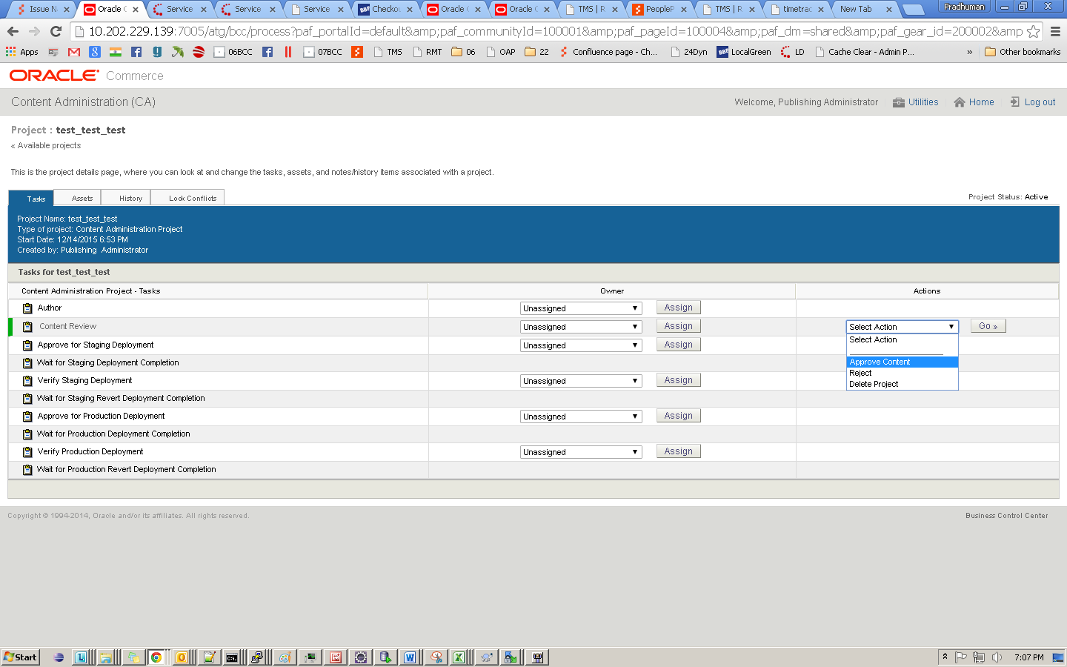

1. Refresh until project get deploy to Staging. Navigate back to the project.
2. Select **‘Accept Staging deployment’** option from the drop down and Click **‘Go’** button and then click **‘OK’** button in flyout at the top.



1. Select **‘Approve and Deploy to Production’** option from drop down and click **‘Go’** button and then click **‘OK’** button in flyout at the top.

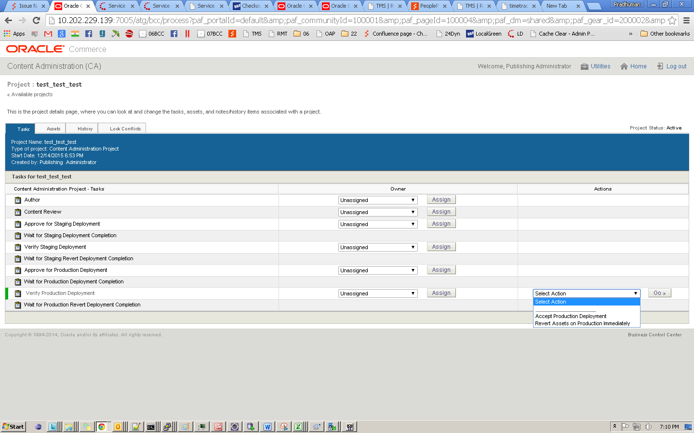

1. Refresh until project get deploy to Production
2. Select **‘Accept Production deployment’** option from the drop down and click **‘Go’** button and then click **‘OK’** button in popup opened at the top.
3. Project is deployed successfully on staging and production.

# Steps to add/update configure Key(s)

1. Create Project under Merchandising



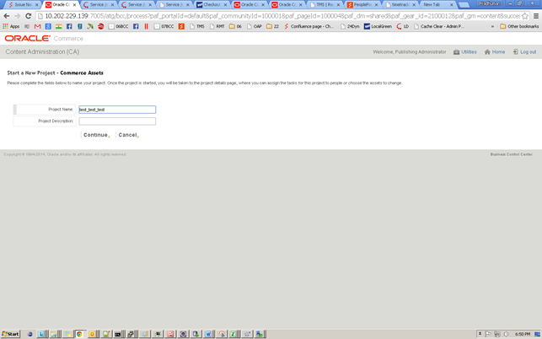

1. Browse through “Web & Mobile 🡪 BBB Config Keys”🡪”Config Keys”
2. 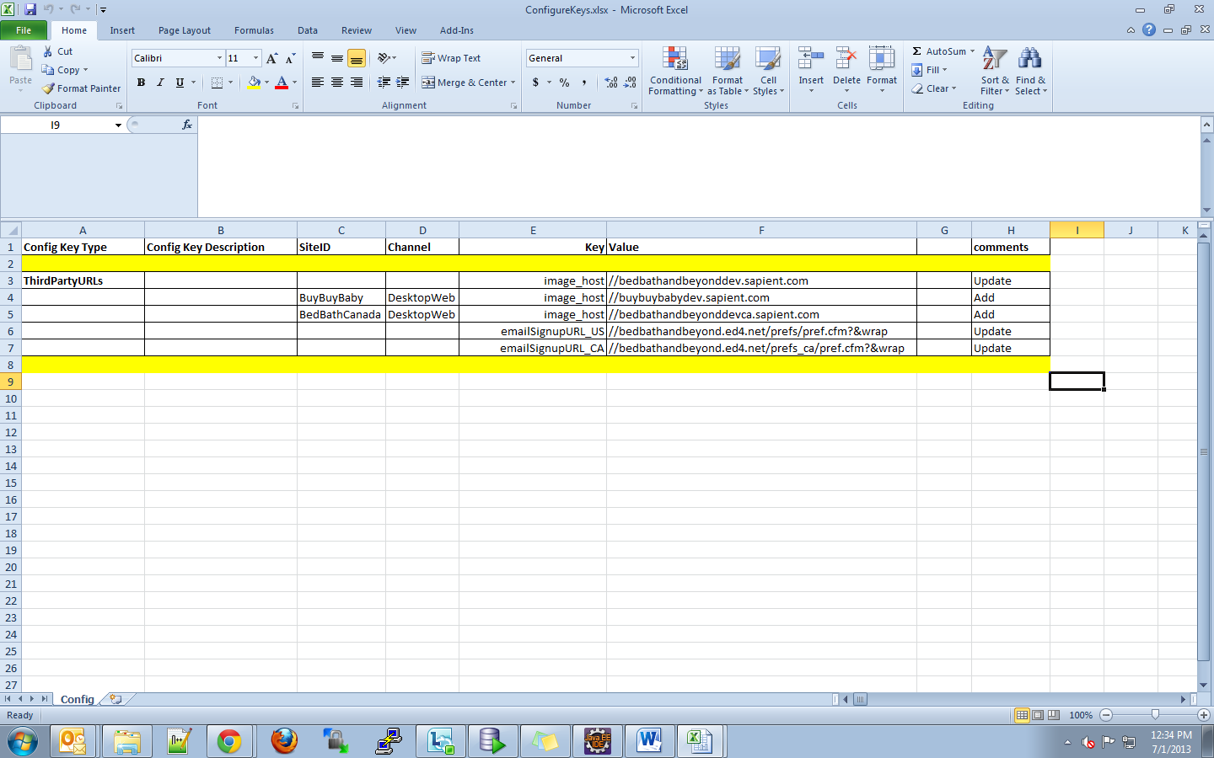Now check in the Excel Sheet under the **Operation** Section
3. If it shows **Update** Follow the steps in 3.2.1, in case of **Add** follow steps in section 3.2.3

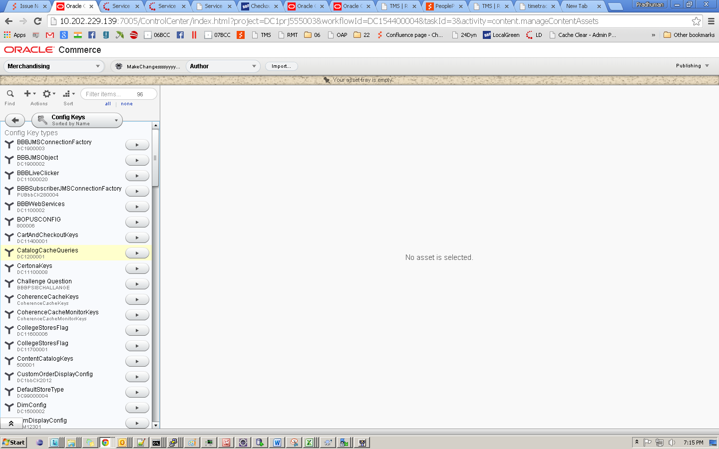

# Update configure Key(s)

Follow the following two steps for updating keys

1. Find the key’s present in the Excel sheet mentioned in section 1 (Release Packet).
2. Select the particular config type e g. ContentCatalogKeys in the left menu.
3. If the site ID and channel columns are empty then follow the instructions below else **skip to section 3.2.2 for update**
4. Choose the key from the list and the update the required property (**Config Value**). Save changes and follow to deployment process.

# Update Translations for configure Key(s)

Follow the following two steps for updating the translations for Config keys

1. Choose the key from the list and the select the translation form the list shown on the basis of SiteID and Channel in the Excel Sheet. Update the required property. Save changes and follow to deployment process

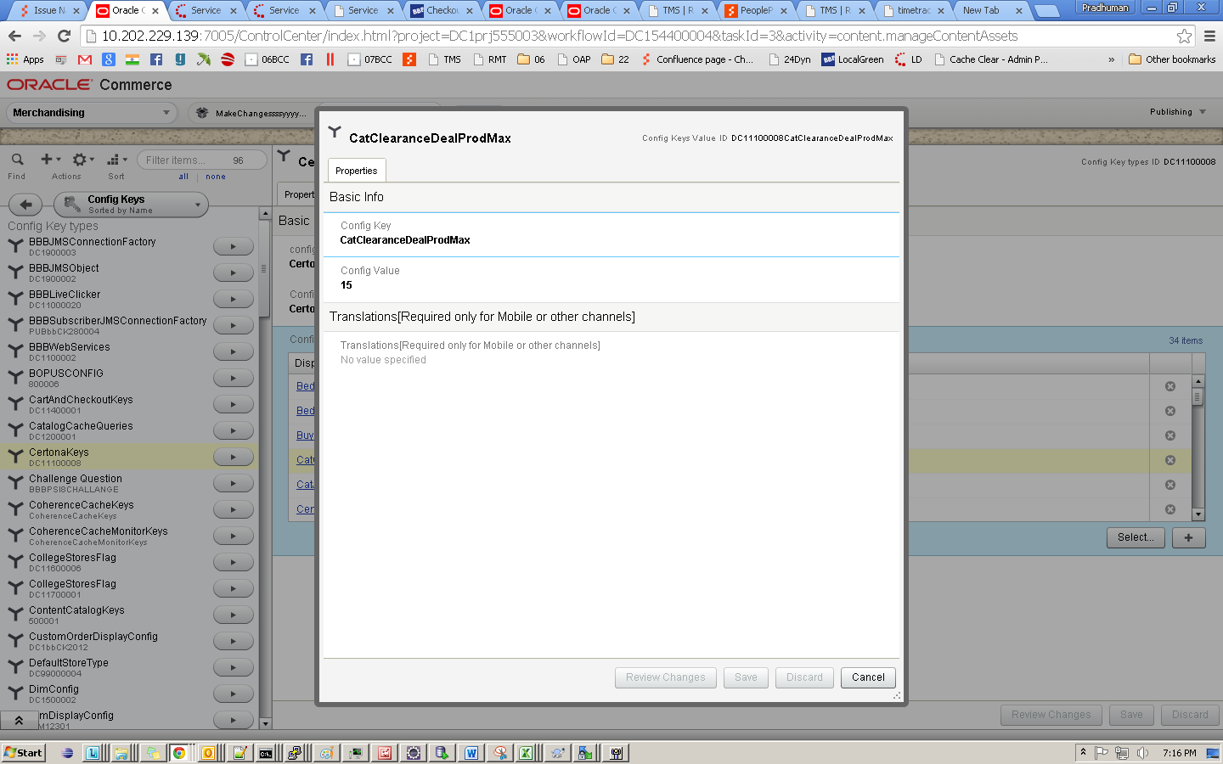

# Add configure Key(s)

Following steps for creating new config keys:

1. If you have to create a new key ,Click on the configKeyType present in above excel sheet e g. ContentCatalogKeys , next click on ‘+’ under the Config key Name Box

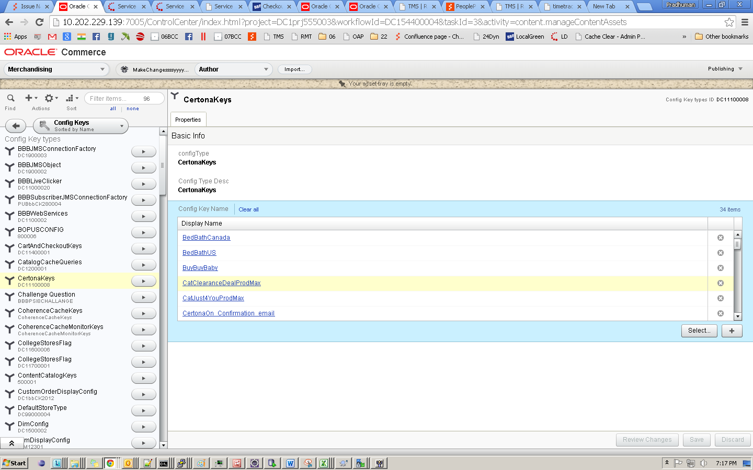

The below window shows for creation of new Key, after entering the values Click on create button as show below. If the side Id and channel columns are empty in the excel sheet then enter the value here else follow the steps in translation section (Section 3.2.4)

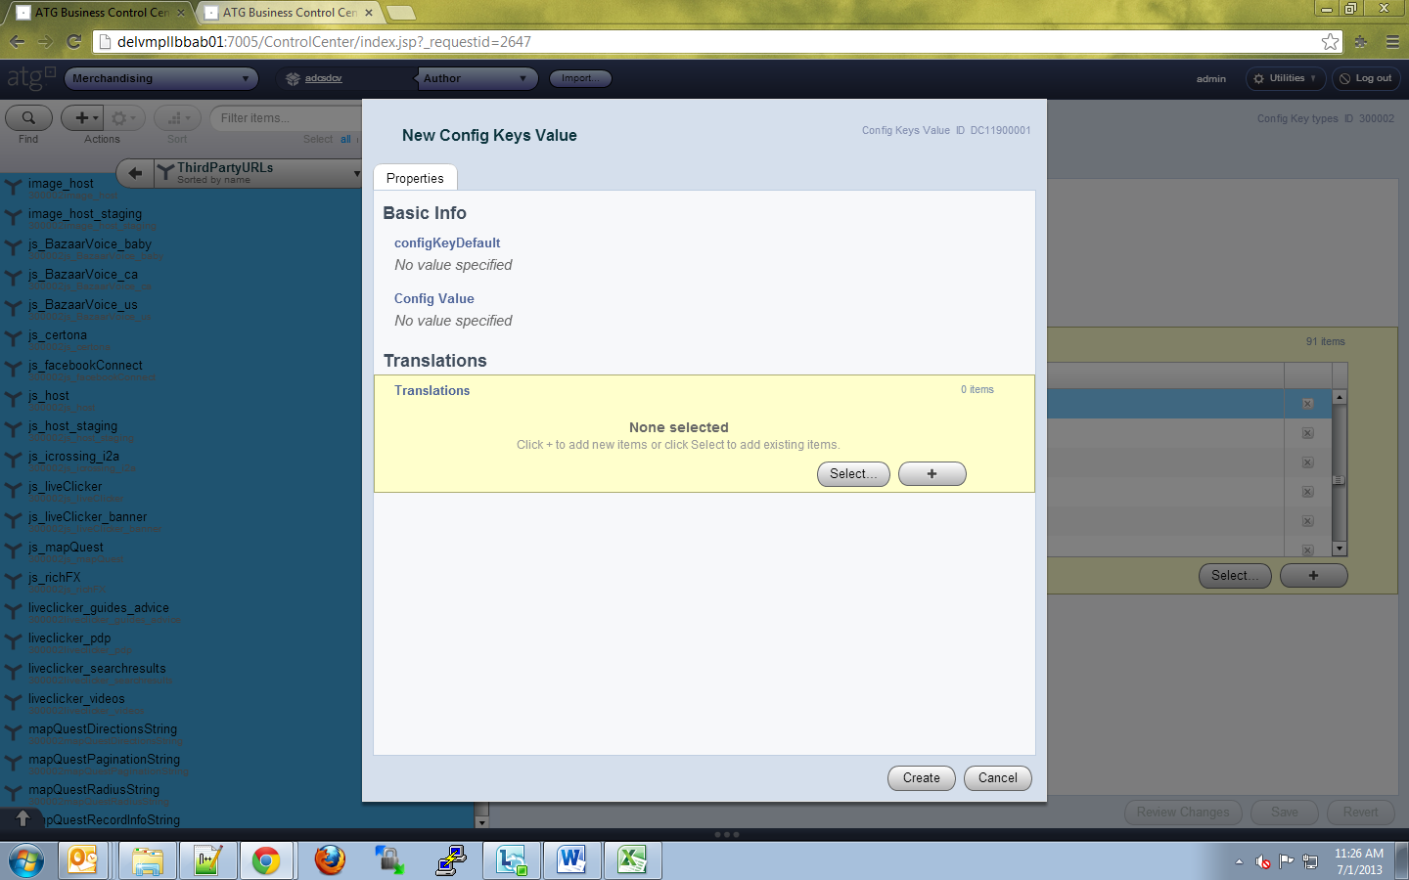 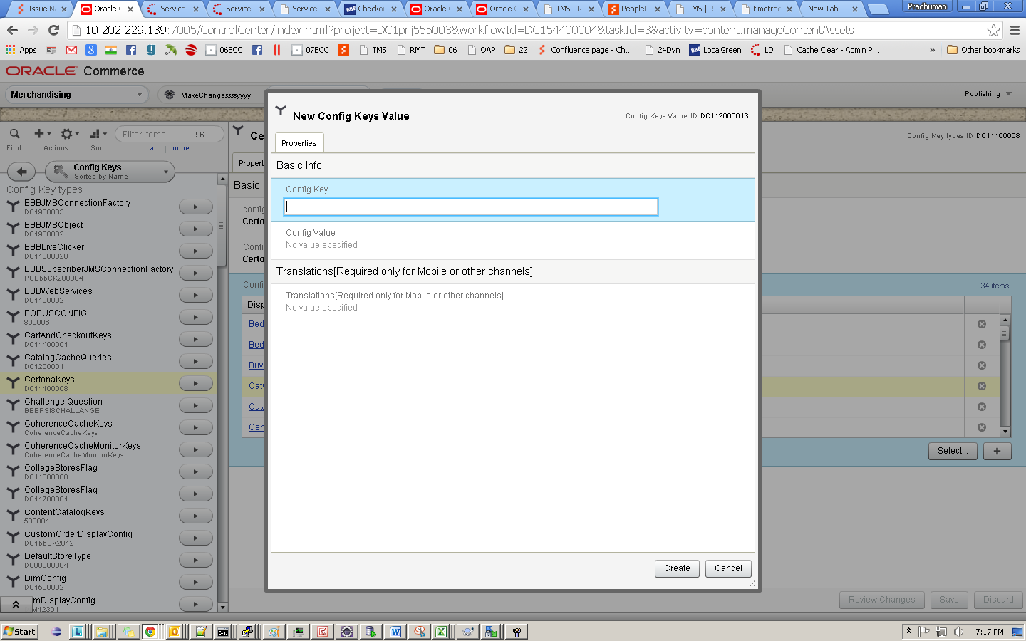

# Add Translation for configure Key(s)

Following steps for creating translations for config keys

1. To add translations select the translations section
2. Now Click on the Plus sign

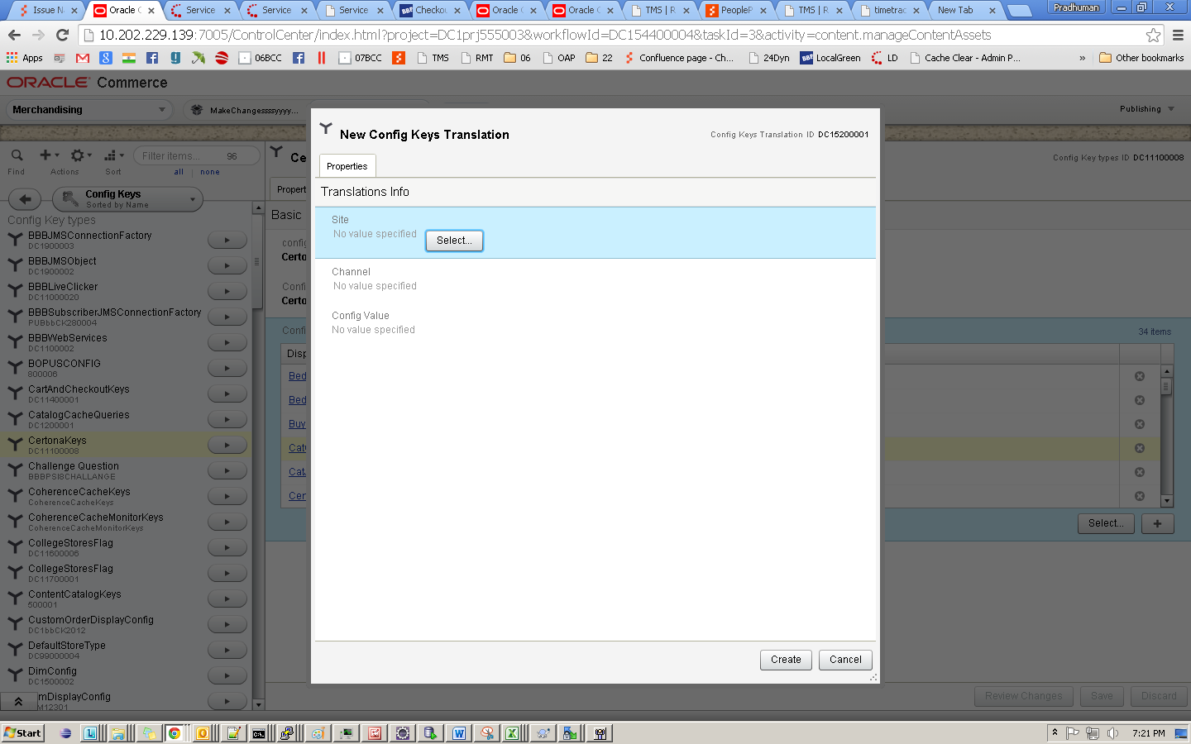

1. Set the Site Id

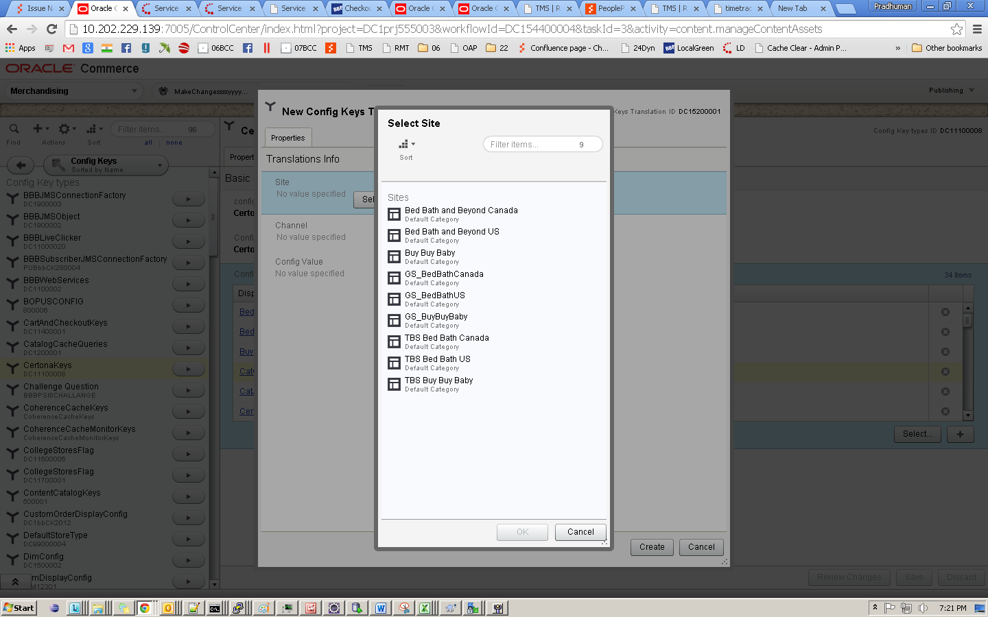

1. To populate the predefined channel list click on Select

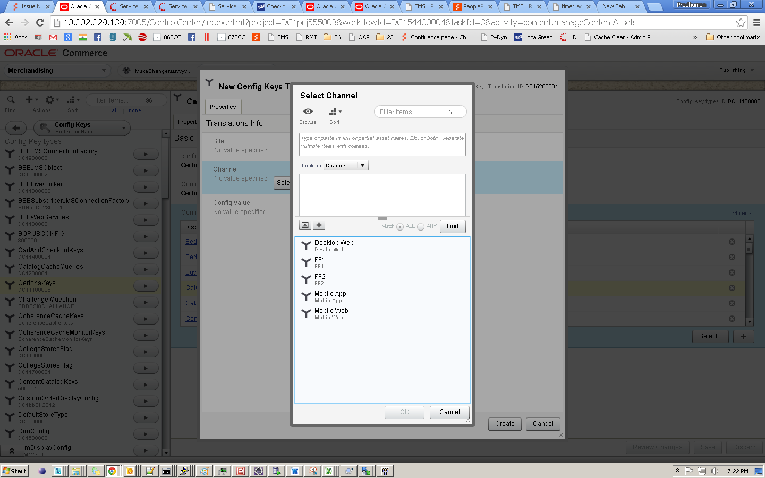

1. Now click on Find and select the appropriate Channel
2. Set the Config Value for the Key.
3. Deploy to staging and production following above steps for deployment.

# Add configure Key(s) Manually

Following steps for creating new config keys in existing Confing type:

1. For Each row in the file : ConfigureKeys

Search the config key type under column “Config Key Type” , Then click on the configKeyType next click on ‘+’ under the Config key Name Box

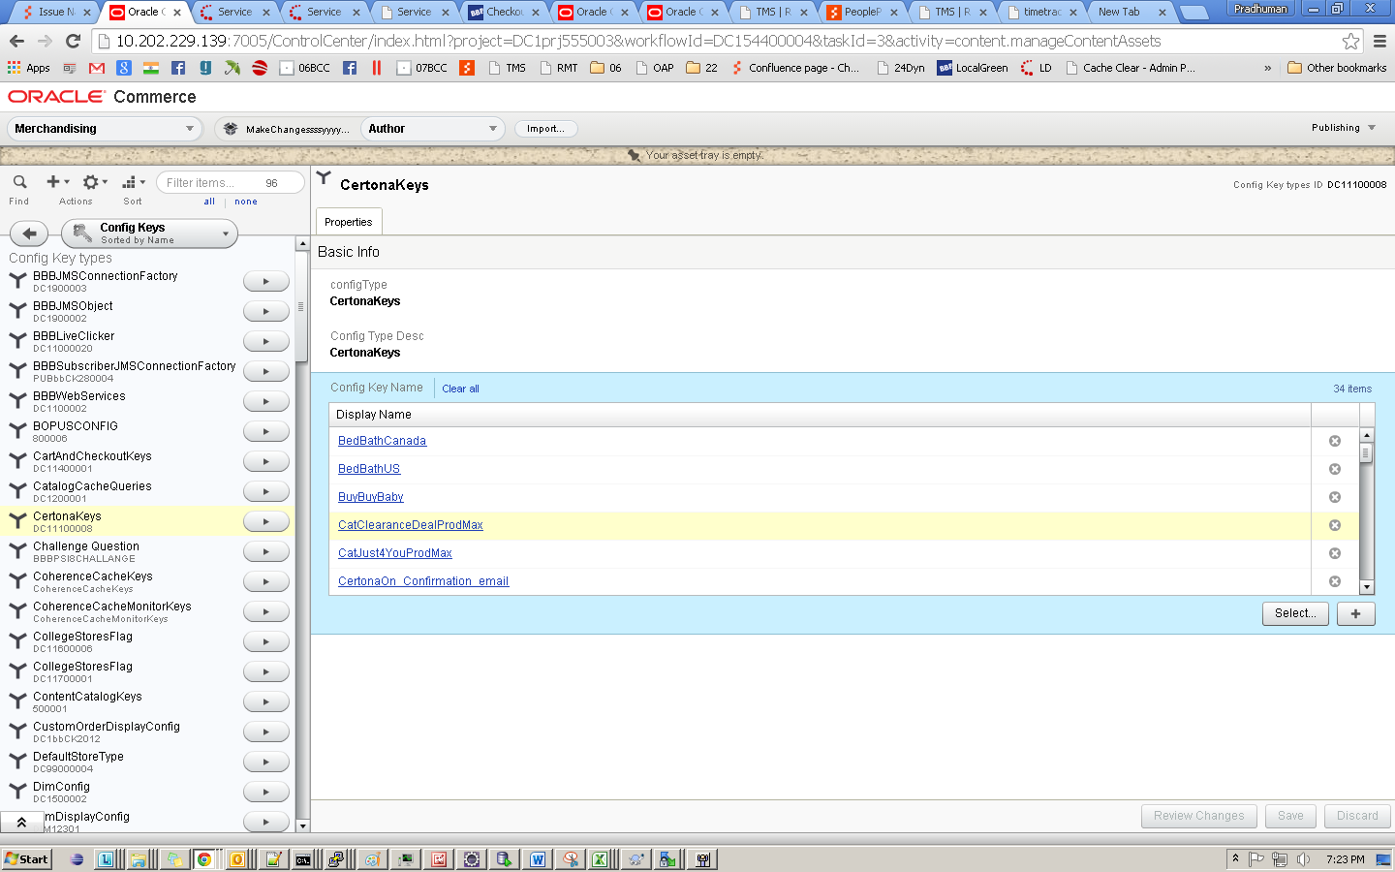

The below window shows for creation of new Key, after entering the values Click on create button as show below. If the side Id and channel columns are empty in the excel sheet then enter the value here else follow the steps in translation section (Section 3.2.4) 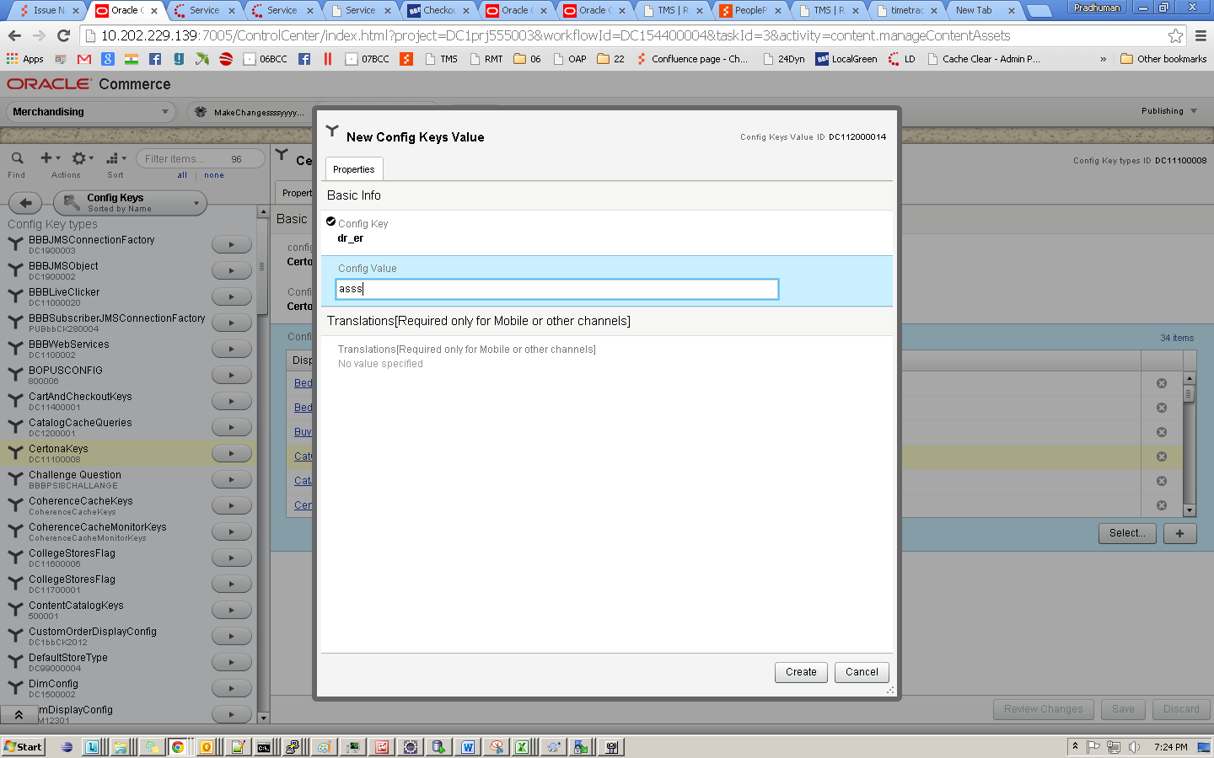

# Update Labels Manually

1. Create Project under Merchandising



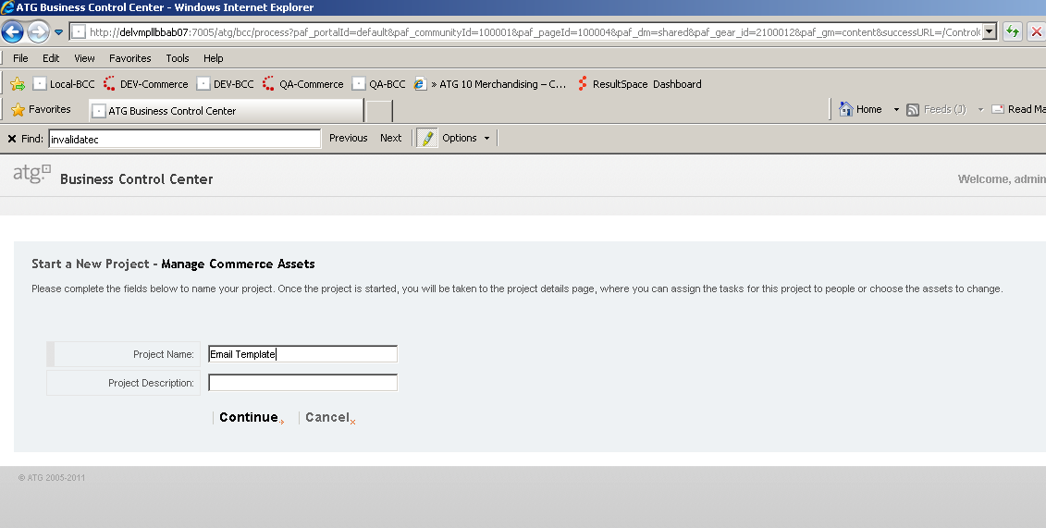

1. Now check the Excel Sheet for ‘Channel’ and ‘Type’ column



1. If the Channel has value “**DesktopWeb**”, traverse through

Web & Mobile 🡪 Labels/Text Areas/Error Message 🡪 Web 🡪 <Labels/Text Areas/Error Messages>.

Otherwise, if the Channel has value “**MobileWeb**”, traverse through

Web & Mobile 🡪 Labels/Text Areas/Error Message 🡪 MobileWeb 🡪 <Labels/Text Areas/Error Messages>.

For eg: as shown in screenshot, browse through Labels/Text Areas/Error Messages 🡪 Web 🡪 Label.

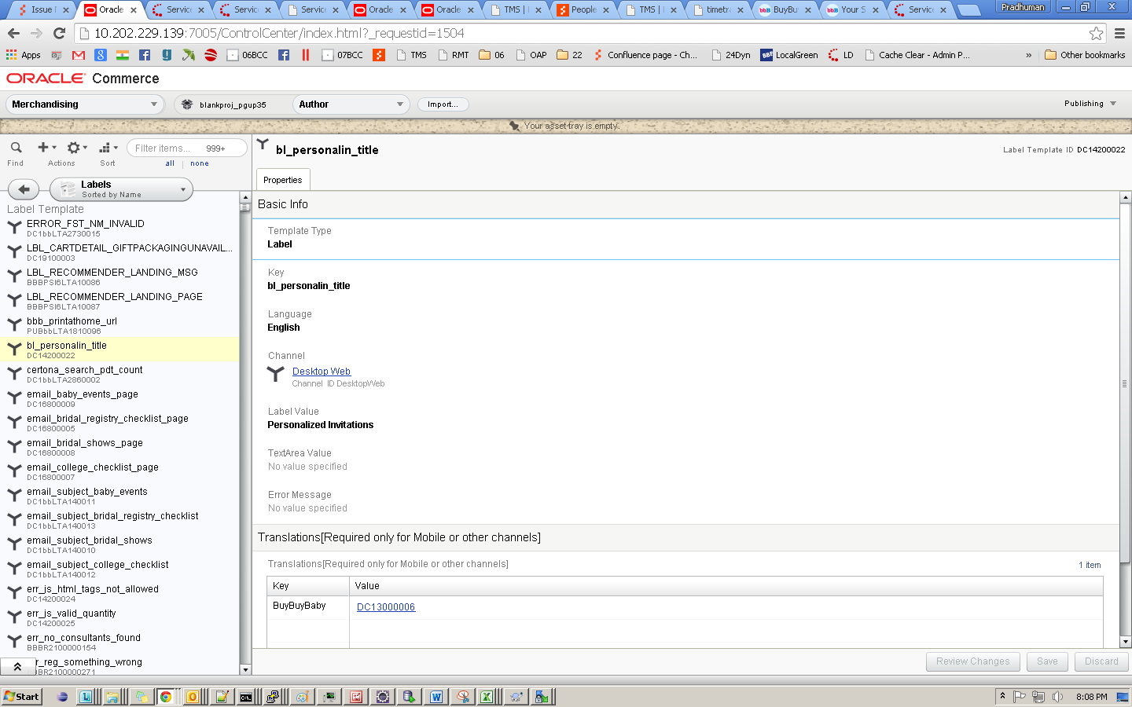

1. Now find the “**label key**” given in excel sheet. Select the label, if Site Id has value “BedBathUs” then update its value given under “**New Value**” in excel sheet. As shown in the screen shot below. If siteId has value other than ‘BedBathUS’ then we need to add the translation for this site Id. To add a translation follow next steps.

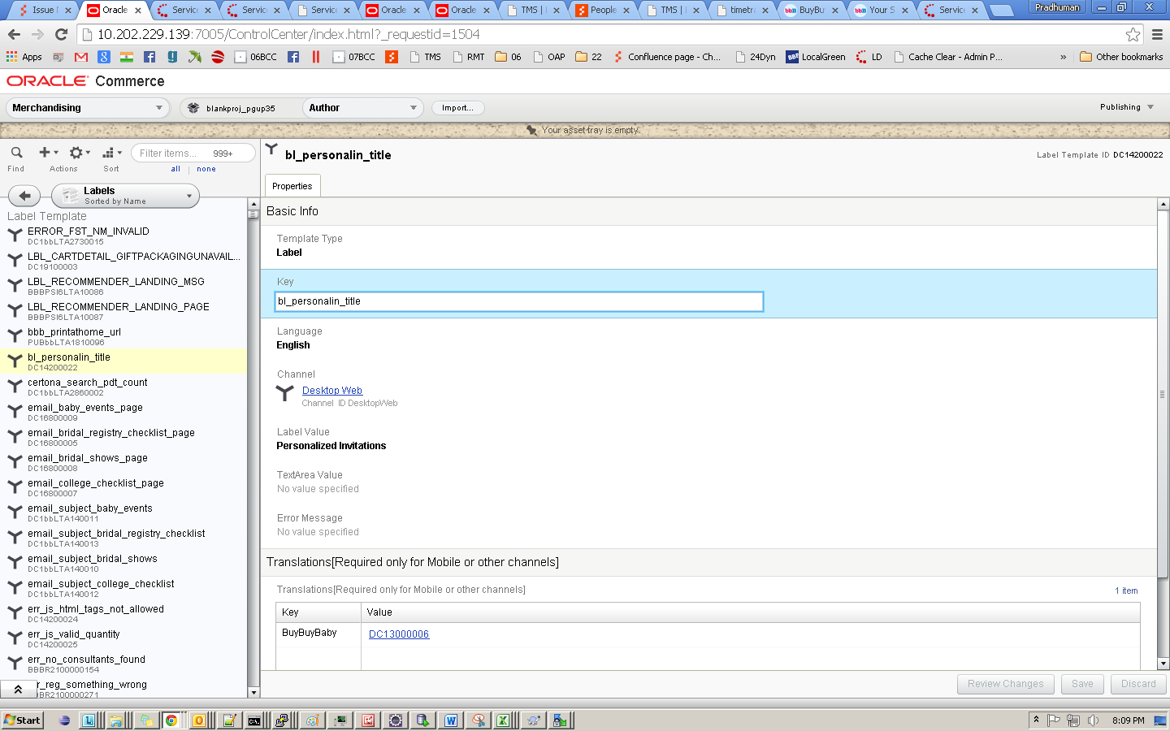

1. Click on the “Translations” Section and then click ‘**+’** button as highlighted in the screenshot below:

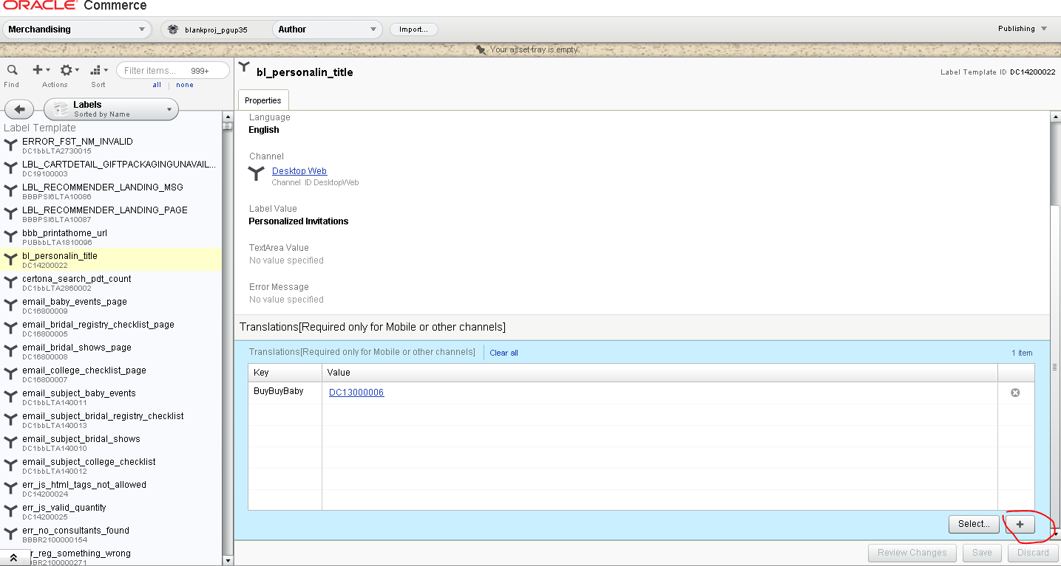

1. Enter the label value and click on ‘Create Value’ button

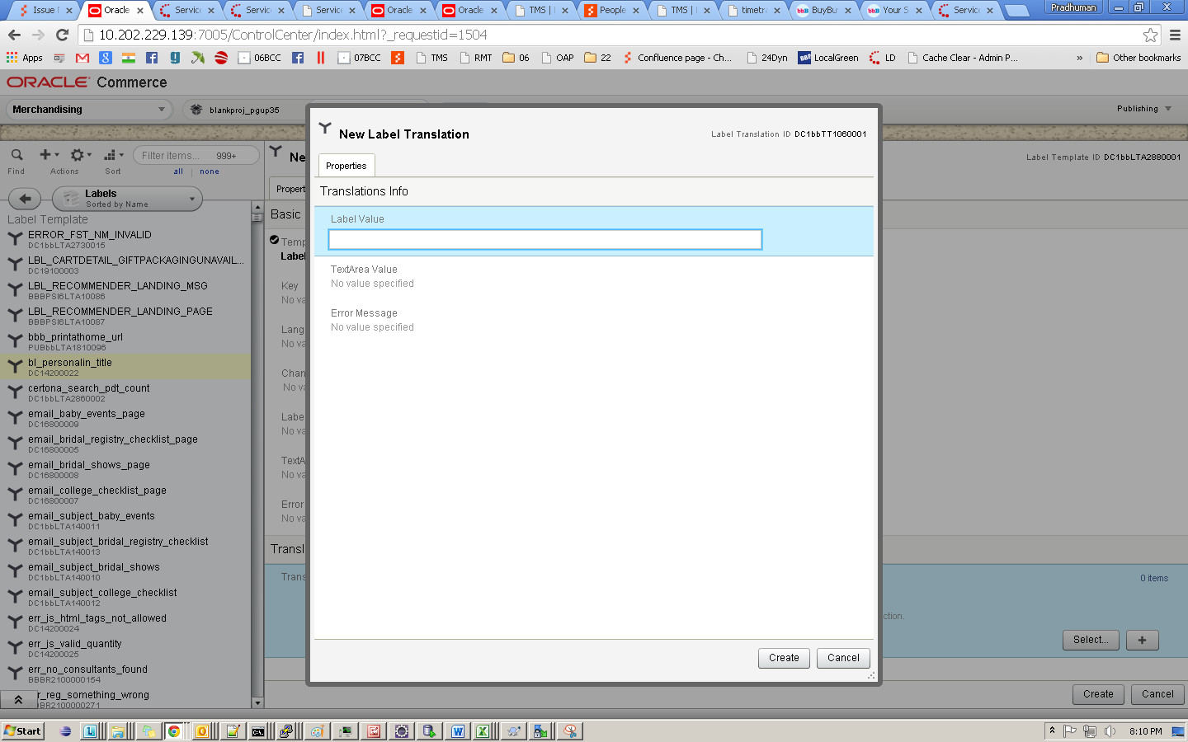

1. Enter the **siteId** from the excel sheet as **Key**

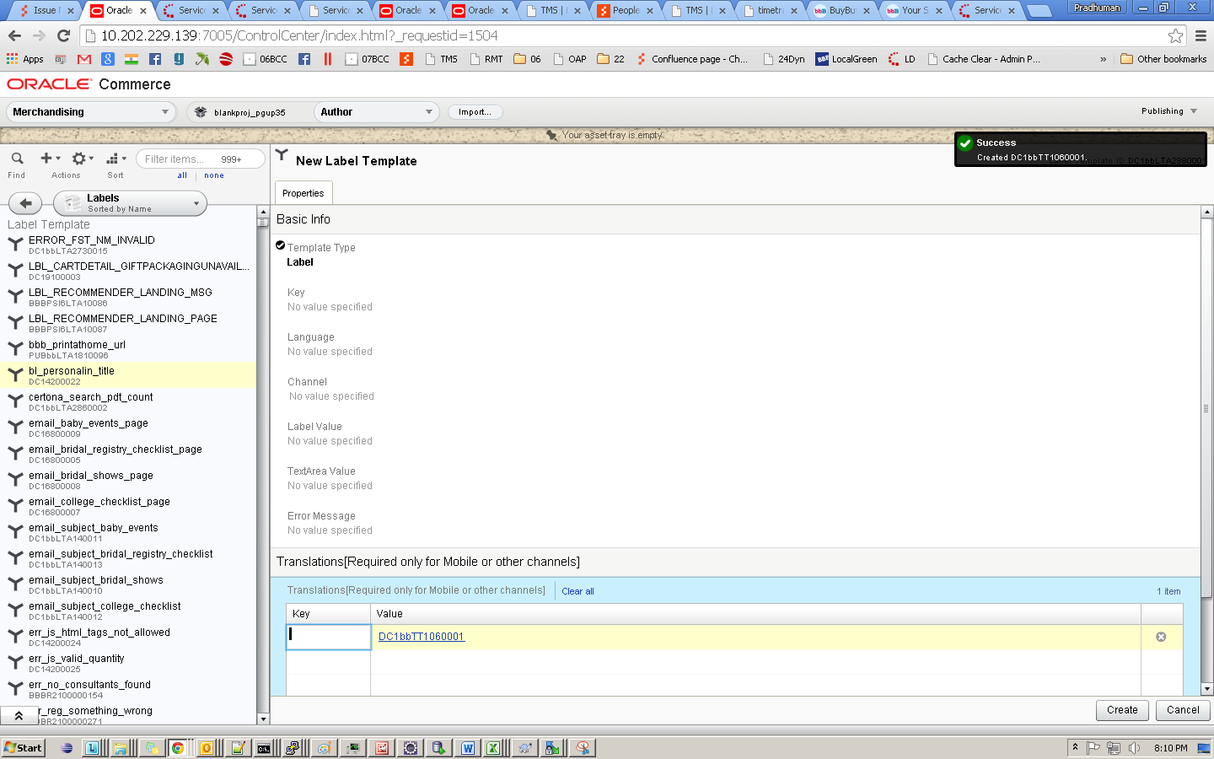

1. Save the changes and follow the deployment process.

# Delete Labels Manually

1. Create content administration by clicking New CA project link on BCC home page.

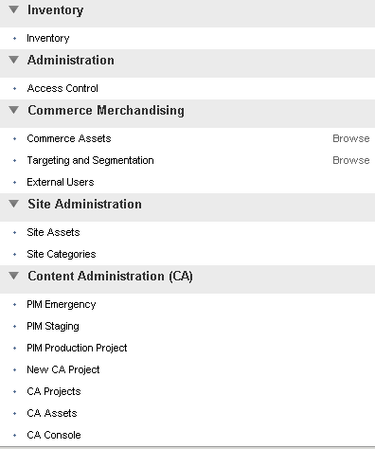

1. Enter project name and click on continue.

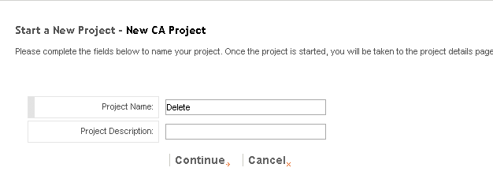

1. Now again go to BCC home page and click on CA Assets.
2. On Assets window select repository as Label Template and Asset type Label Template.

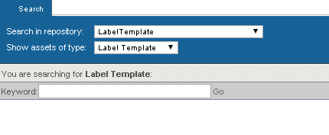

1. Enter label id in search box. Then click on Go.

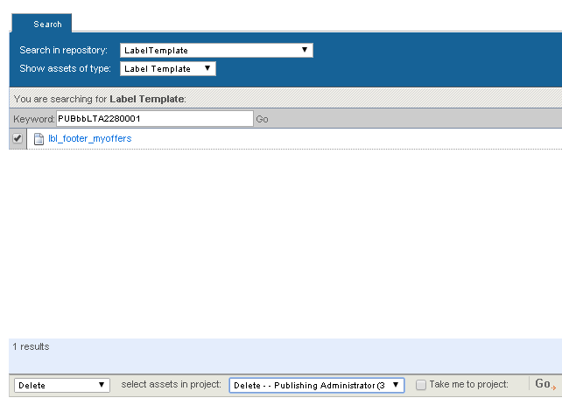

1. Select check box in front of label name. Then select Delete from bottom drop down.Select project in your project drop down. Then click on Go on bottom bar.
2. Repeat this process for all labels . For label translations select asset type as Label Translation in drop down.

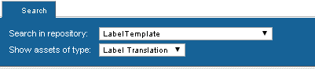

1. While selecting last label or label translation select Take me to project checkbox.

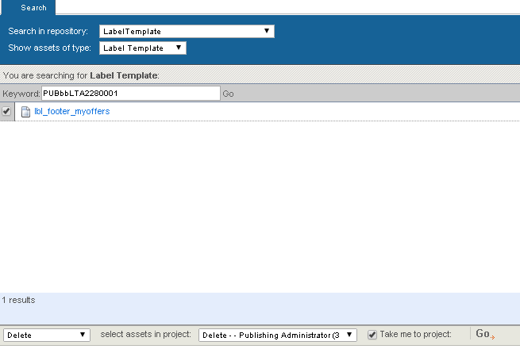

1. Deploy the project.

# Delete Configure Keys Manually

1. Create New Project by clicking New CA project link on BCC home page.

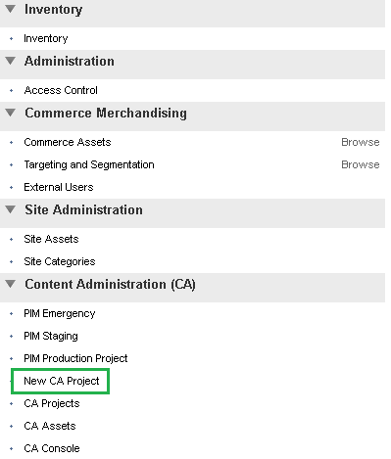

1. Enter project name and click on continue.

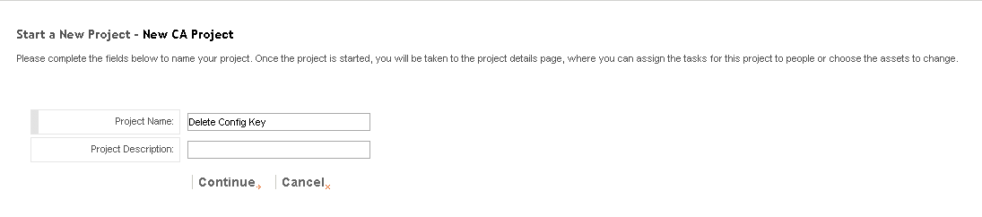

1. Now again go to BCC home page and click on CA Assets.

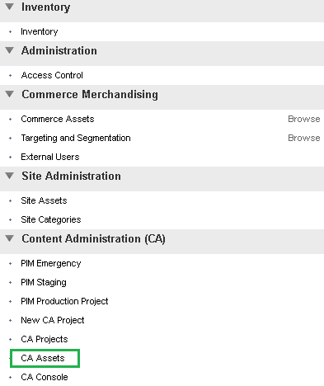

1. On Assets window select repository as Configure Keys and Asset type Config Keys Value.

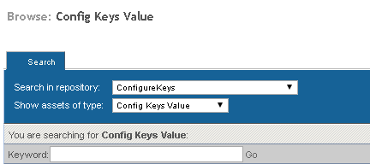

1. Enter Configure Key Id (present inside **key** column in the ConfigureKeyManual.xls sheet) in search box. Then click on Go.

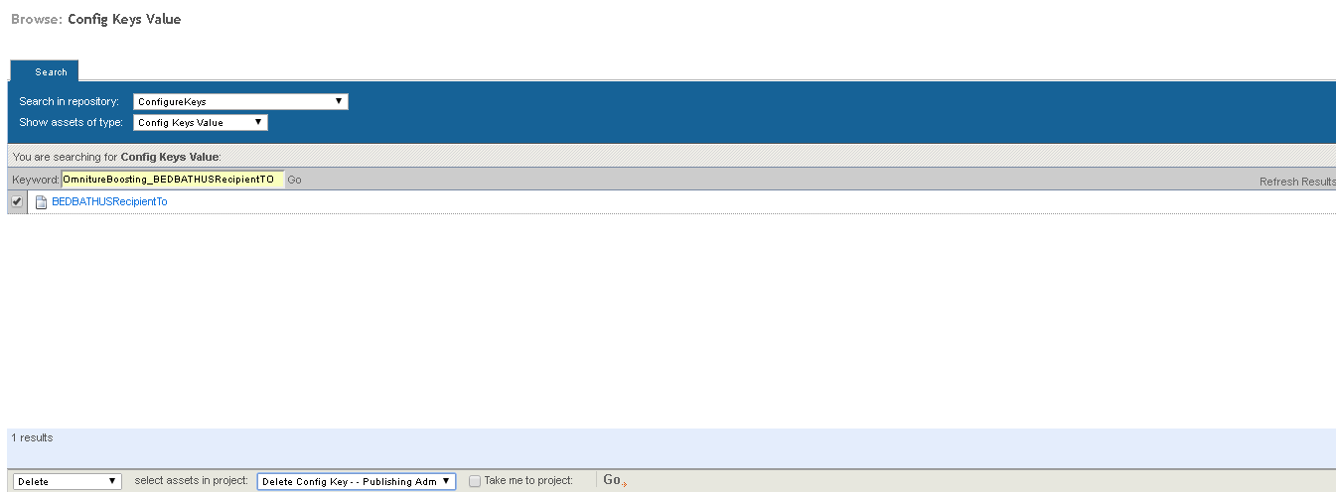

1. Select check box in front of Config Key. Then select Delete from bottom drop down. Select project in your project drop down. Then click on Go on bottom bar.
2. Repeat this process for all the Configure Keys mentioned in sheet.
3. While selecting last Configure Key select Take me to project checkbox.
4. Click on Task tab as shown below.

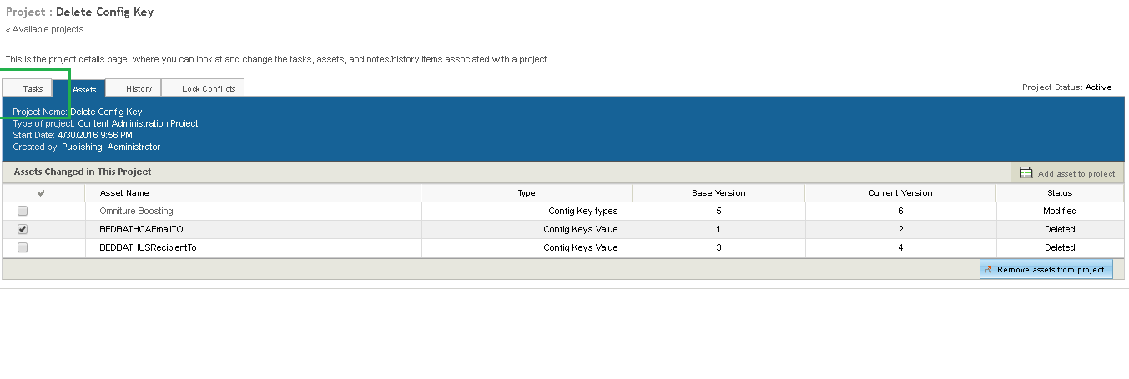

1. Deploy the project.

# Delete Challenge Questions Manually

1. Create New Project by clicking New CA project link on BCC home page.



1. Enter project name and click on continue.

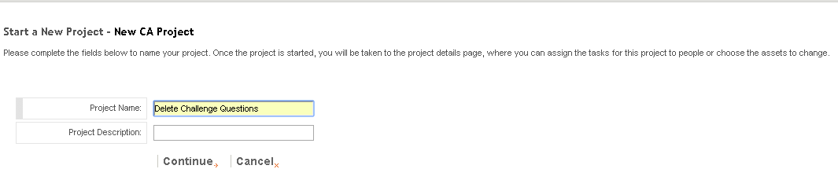

1. Now again go to BCC home page and click on CA Assets.



1. On Assets window select repository as Challenge Questions Repository Keys and Asset type questions.

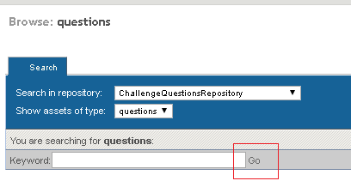

1. Click on Go.

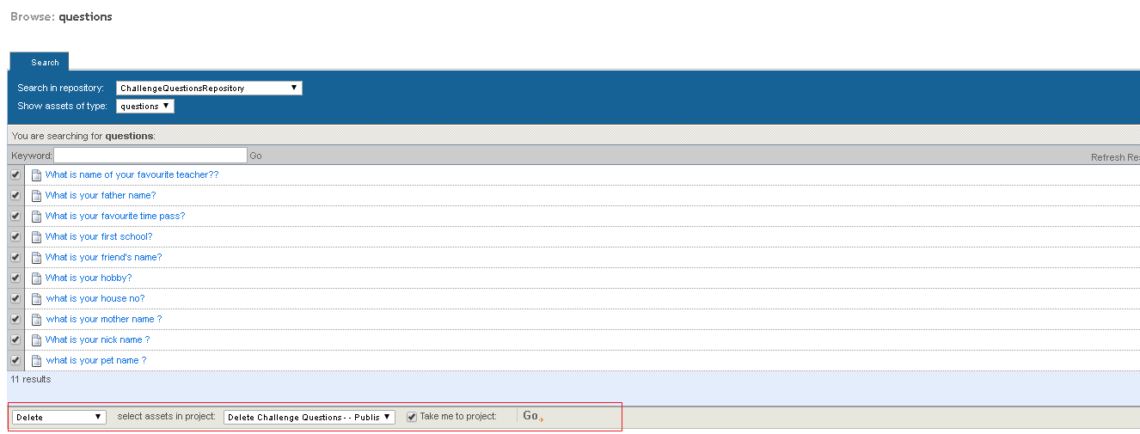

1. Select check box in front of all the challenge questions. Then select Delete from bottom drop down. Select project in your project drop down, select Take me to project checkbox. Then click on Go on bottom bar.
2. Click on Task tab as shown below.

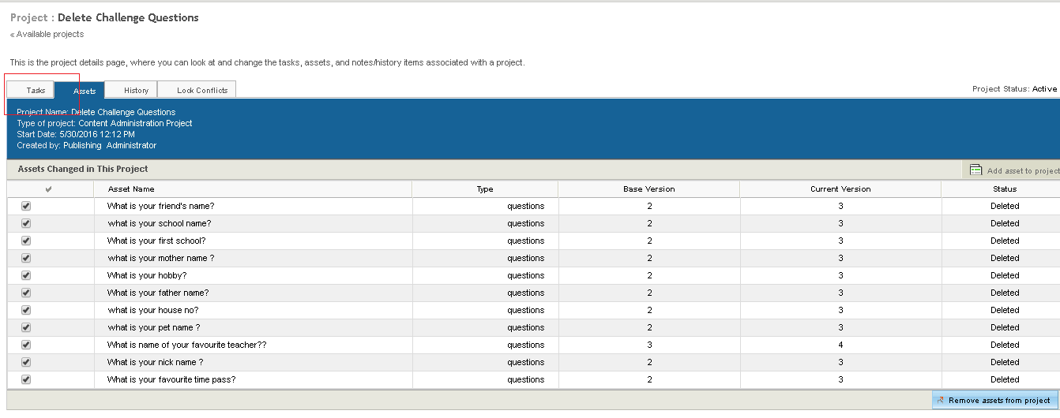

1. Deploy the project.